IRB Approved at the Study Level
Sep 25, 2023
#38560692.0
Social Work Field Placements of Students with Adverse Childhood Experiences
An Interpretative Phenomenological Inquiry
Recruitment

What: For my dissertation study as a doctoral student at Wurzweiler School of Social Work at Yeshiva University, I am seeking current social work students who endured adverse childhood experiences and have participated in a field education placement. If you meet these criteria, you are invited to complete a brief questionnaire and participate in an approximately 60- 90-minute interview.

Who: Advanced standing or second year master’s level social work students with a history of adverse childhood experiences. These experiences may include but are not limited to physical, sexual, and/or emotional abuse, parental incarceration, parental mental health, and parental substance abuse.

When: Interviews will be scheduled according to what works for you.

Where: All interviews will be conducted online via zoom. All interviews will be confidential, and students will have the option to have the video on or off.

Why participate: You are being asked to participate to help us understand the influence of adverse childhood experiences on the social work students field education placement. Through this study, the researcher hopes to develop educational resources, contribute to policy and research, explore a best practice model for teaching and supporting social work students with experiences of childhood adversity.

If you meet these study criteria, please click the link below to complete the demographics questionnaire and consent form. Each student that participates will receive a 15$ Amazon Gift Card. I appreciate your help!

Link to Consent Form and Demographics Questionnaire: https://yeshiva.co1.qualtrics.com/jfe/form/SV_cvAnLpOaCmczhDE

Contact: Emily Murphy, LMSW, Doctoral Candidate
(973) 879/4905/Emily.murphy@yu.edu

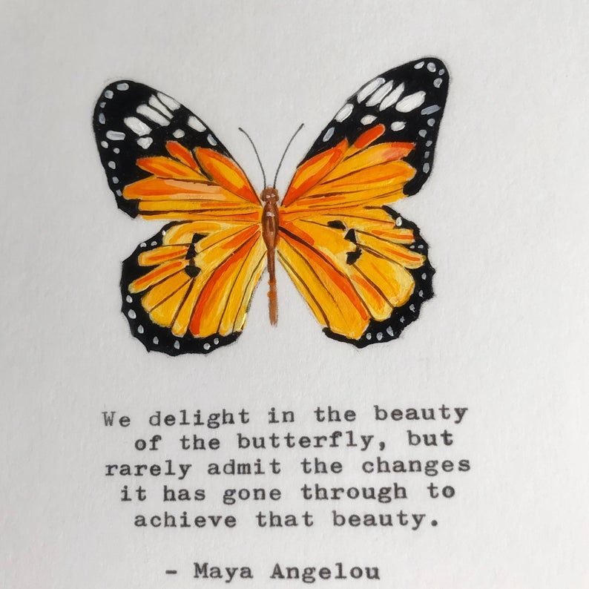

Mental Health Resources

The following is a list of mental health resources within the New York City region:

- NYC Mobile Crisis Team

Number: 888-NYC-WELL (888-692-9355)

Mental health crisis mobile response team.

- NYC Care

Number: 646-NYC-CARE (646-692-2273)

Support to access mental health services at low costs.

- NYC Well

Number: 888- NYC- WELL (888-692-9355)

Mental health support via phone, text, or chat.

The following is a list of national mental health resources:

- 988 Suicide and Crisis Hotline

Number: 988

Mental health support via call or text.

- SAMSHA’S National Helpline

Number: 800-662-HELP (800-662-4357)

Treatment referral routing services.

