Social Work Ethics and Boundaries: A Critical Examination
Monday, July 31st, 2023
noon to 4 pm (CST) – virtual, live interactive training
4 CEUs available in interactive ethics

Debbie Minsky-Kelly, LCSW, is Field Director and Clinical Assistant Professor at the Carthage College school of social work. Debbie’s 25+ year career as a social worker includes leadership in mental health and addiction treatment with children, teens and families, most recently as director of a mental health facility. Debbie’s background includes work in child welfare, domestic violence, homeless healthcare, private practice and childhood trauma. Debbie has presented at local, national and international conferences and has published research in the area of the healthcare system’s response to domestic violence and on the ethical questions raised by social workers embracing the medical model of mental health delivery. Debbie was selected as Distinguished Teacher of the Year at Carthage in 2021. Debbie has a strong interest in ethical practice related to trauma and resilience, which is based on her teaching of a semester course on trauma to undergraduate students since 2019.
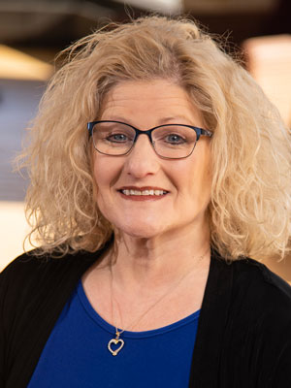

Workshop summary: The social work profession has undergone transformational changes since its inception in the late 1800s. The original commitment of the profession was to serve the poor and other marginalized groups and to bring the public’s attention to large-scale macro-level social problems. With increasing numbers of social workers entering the private sector and focusing on individually-based micro struggles, the Code of Ethics has evolved to accommodate and address the intricacies of individually-focused models of care. This workshop will examine these changes and ask critical questions about our identity as a profession. In what ways do our current professional values and ethical mandates create conflicts with our profession’s historical commitments to be agents of social change? The current epidemic of loneliness, combined with our historical and political context, will serve as a backdrop for the urgent need for a strong and values-driven reexamination of our identity as a profession.

Workshop cost: $100 includes the workshop, emailed handouts, and CEU certificate of completion. Register at this link (you might need to hover over the link and click CTRL + left click on your mouse).
Proceeds from this workshop will benefit the field component of the Carthage College BSW program.

For more information, please contact Debbie Minsky-Kelly at dkelly1@carthage.edu

