Ethics and Boundaries in Trauma Work: Unique Challenges and Opportunities
Wednesday, July 27th, 2022
noon to 4 pm (CST) – virtual, live interactive training
4 CEUs available in interactive ethics

Debbie Minsky-Kelly, LCSW, is Field Director and Clinical Assistant Professor at the Carthage College school of social work. Debbie’s 25+ year career as a social worker includes leadership in mental health and addiction treatment with children, teens and families, most recently as director of a mental health facility. Debbie’s background includes work in child welfare, domestic violence, homeless healthcare, private practice and childhood trauma. Debbie has presented at local, national and international conferences and has published research in the area of the healthcare system’s response to domestic violence. Debbie was selected as Distinguished Teacher of the Year at Carthage in 2021. Debbie has a strong interest in ethical practice related to trauma, which is based upon her teaching of a semester course on trauma to undergraduate students since 2019.
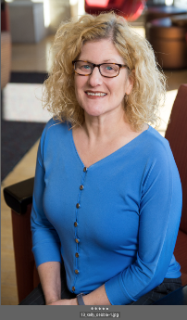

Workshop summary: The subject of trauma is gaining increased attention as a significant public health issue. Social workers and other mental health professionals are on the front lines of addressing the multitude of social ills that result from trauma exposure. This workshop examines the unique ethical questions raised by our work with trauma survivors. Participants will explore the adequacy of current definitions of trauma and ways our profession can address traumatizing effects of toxic stressors such as racism, poverty and other forms of oppression. The unique ethical and boundary questions raised by trauma work will be reviewed. This presentation will look at ethical issues of trauma work through a social justice lens. This program has been approved for ethics CEUs by the National Association of Social Workers, Wisconsin Chapter.

Workshop cost: $100 includes the workshop, emailed handouts, and CEU certificate of completion. Register at this link (you might need to hover over the link and click CTRL + left click on your mouse).
Proceeds from this workshop will benefit the field component of the Carthage College BSW program.

For more information, please contact Debbie Minsky-Kelly at dkelly1@carthage.edu

