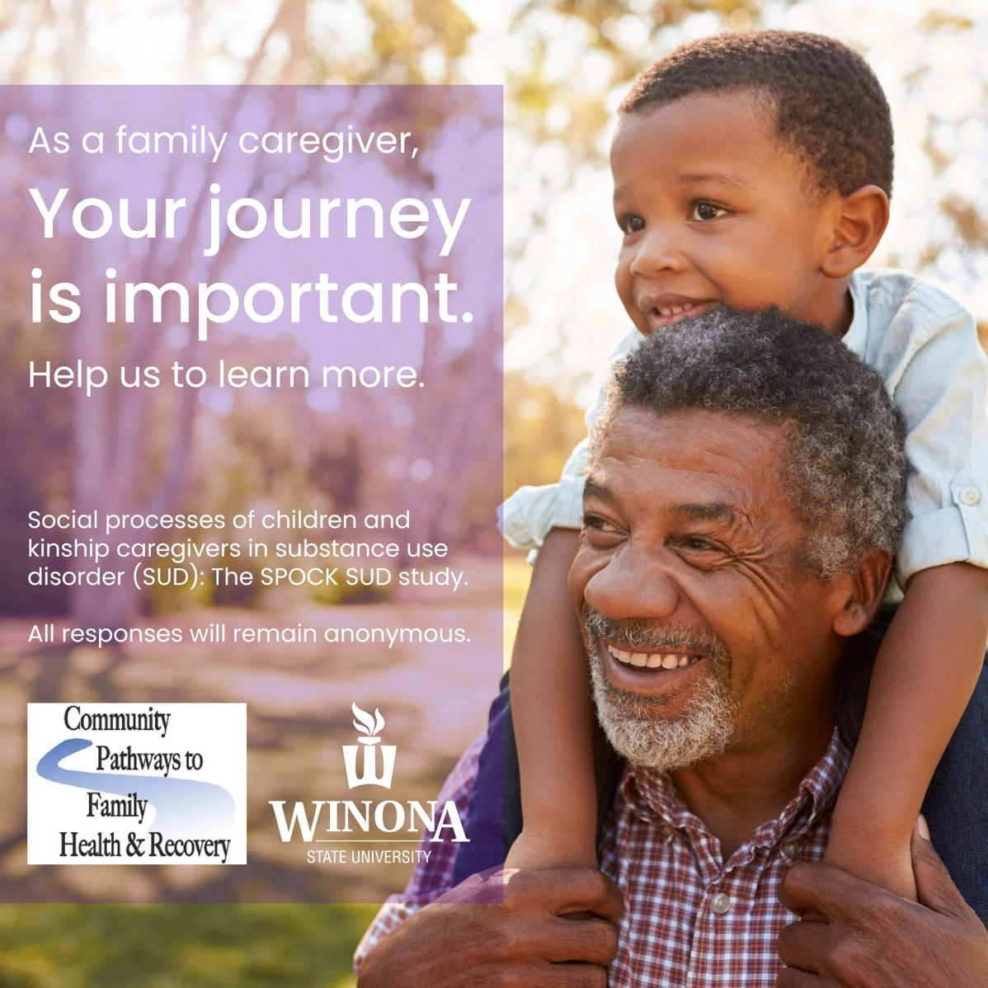

Are you a family member or close family friend caring for a child whose parent is struggling with substance use disorder (addiction to alcohol or drugs)?

We want to learn from you!
Kinship caregivers often provide care without enough resources and assistance to face the challenges of raising children. Your input is important to us and will help us learn what needs and supports would benefit you and other families.
Please visit https://tinyurl.com/52988ame to complete an anonymous survey.

