Sharing Kit for the
Inaugural Grand Challenges for Social Work Doctoral Awards
Funded by the New York Community Trust

This sharing kit is being offered to help friends of the Grand Challenges for Social Work to promote its call for doctoral students to apply for its inaugural doctoral awards cohort. The Doctoral Awards are an exciting new element of the GCSW’s Go•Grander campaign and are generously funded by the New York Community Trust.

We encourage you to help promote this award via your university social media channels, newsletters, websites, etc., as well as your own networks and personal social media, as appropriate.

If you have any questions, please contact GCSocialWork@ssw.umaryland.edu.

Facebook/LinkedIn/Newsletter/Blog Post

The Grand Challenges for Social Work is calling for doctoral students to apply for its inaugural awards cohort, generously funded by the New York Community Trust.

Doctoral awards of $3,000 are available to support dissertation or capstone expenses of social work doctoral students whose work addresses at least one of the Grand Challenges. It is expected that these research findings will ultimately be turned into proposals for policy and practice changes. One award will be made for each of the 13 Grand Challenges.

Please share this information widely with your networks!

Applications are due by December 9, 8pm ET.

View application guidelines here: grandchallengesforsocialwork.org/doctoral-awards
Questions? Please contact GCSocialWork@ssw.umaryland.edu.

Image Download Link
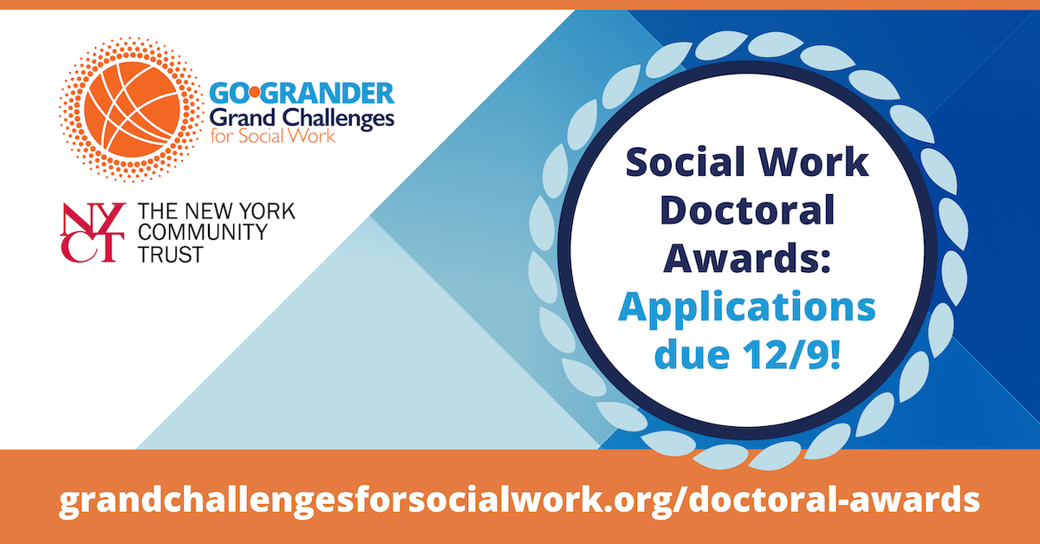
___________

Sample Tweets
Tweet #1
Fellowship alert! #Socialwork doctoral students are invited to apply by Dec. 9 for @GCSocialWork/@NYCommTrust's award program & receive $3K for capstone/dissertation projects related to the Grand Challenges.
Learn more or join an info session: https://grandchallengesforsocialwork.org/doctoral-awards/

Tweet #2
Are you or do you know a doctoral student conducting a dissertation/capstone related to the Grand Challenges for Social Work? @GCSocialWork’s new doctoral award grants 13 awardees in the inaugural cohort w $3K in fellowships & mentoring. Apps due: 12/9 https://grandchallengesforsocialwork.org/doctoral-awards/

Tweet #3
Application Open! Funded by @NYCommTrust, the inaugural @GCSocialWork Doctoral Award grants $3K for doctoral student capstone/dissertation projects related to each of the Grand Challenges for Social Work. Join an info session (10/27 or 11/1) & learn more: https://grandchallengesforsocialwork.org/doctoral-awards/

Image Download Link

